1. Create yaml file for creating pod first

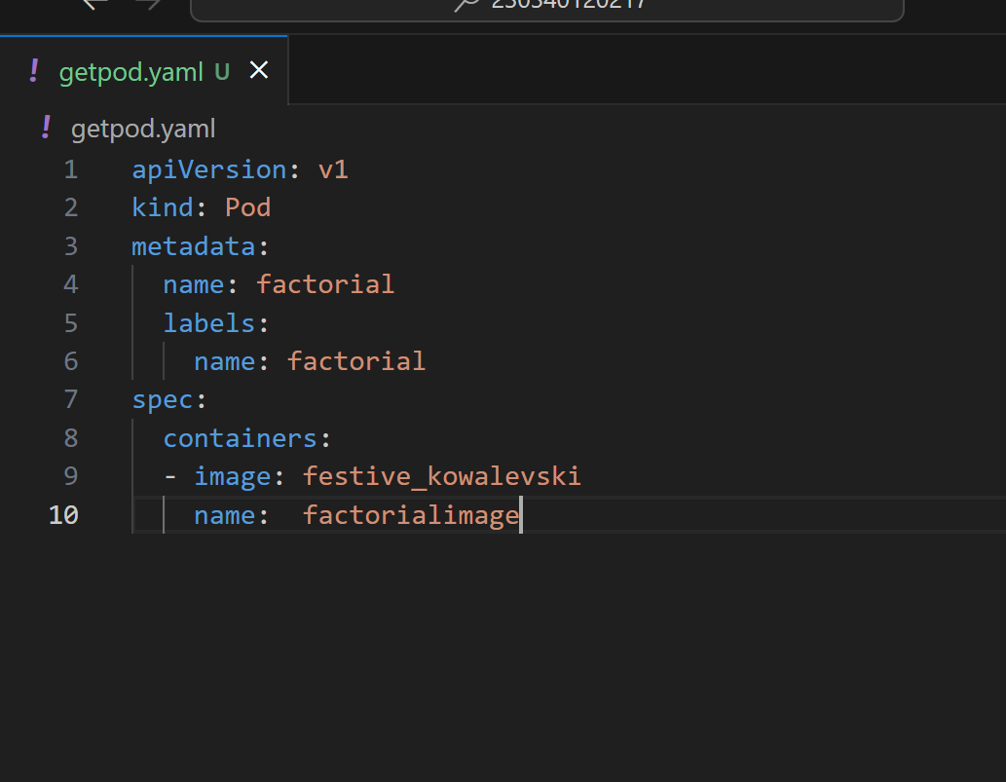

2.

Created pod but it is not running

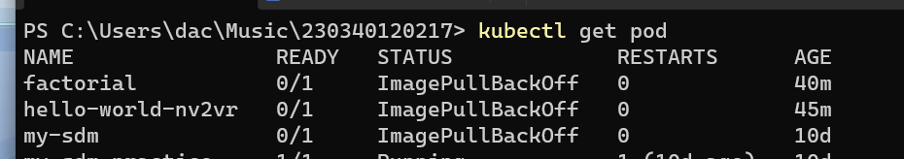

Tried everything

1. 0